Microsoft excel tutorial for beginners
subtitle

Heading 1

Heading 2

Heading 3

Heading 4

General
Idea | Method in Python | Method in Java | Info in Java
Comparing strings. | __lt__ or __gt__ dunder method | "hello".compareTo("Why") | You have to implement Comparable interface.
Indexing | x[4] | x.charAt(4)
Substring | x[:3] | x.substring(0,4)
Negative iteration | 'kazim'[3:1:-1] | Use StringBuilder and do for( ; ; ;) loop. | U can use stream collection but they get very verbose for simple iteration and loose readability.
Casting int, string to its Ascii equivalent |  | Char letter=’a’  int letter=(int) a | Note: Use single string for chars.
String to char array | “kazim”.split(“”) | x.toCharArray()
Autoboxing |  | Integer.valueOf(int) | Convert primitive type int data into Integer object
Unboxing |  | obj.get(1).intValue | Convert back to primitive type
Integer to Binary |  | String x= (String) Integer.toBinaryString(-4);
Random numbers |  | Random random = new Random();  System.out.printf("%d%n",random.nextInt(0,10));

Printf Formatting
Repeat | System.out.printf("Name:%s ".repeat(3),"Sahil","Sadik","Talib"); |  | String repeated
String | %s
Integer | %d
Float | %.2f
Boolean | %b
Char | %c
124000 → 1,24,000 | %,d

Tricks
contains |  | String x=”q”  “qQ”.contains(x) | If user enter uppercase or lowercase Q for quit out of the loop.

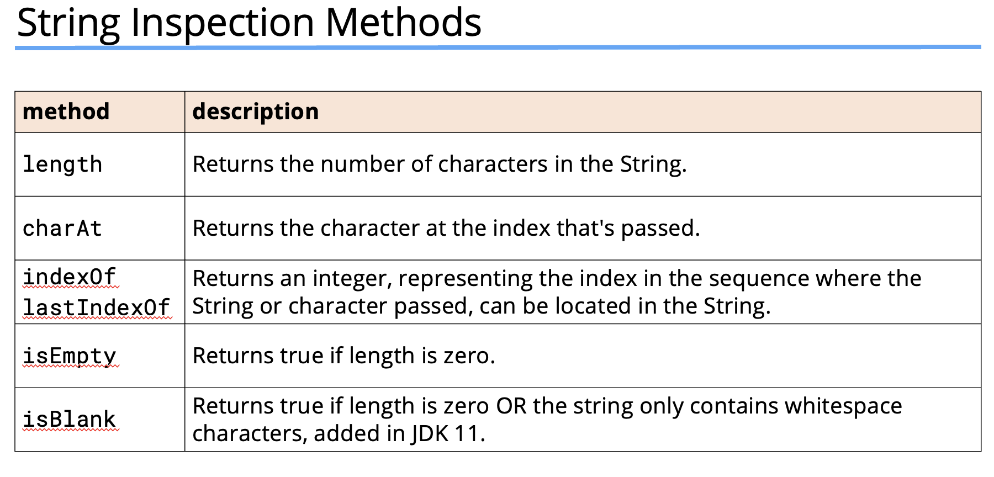
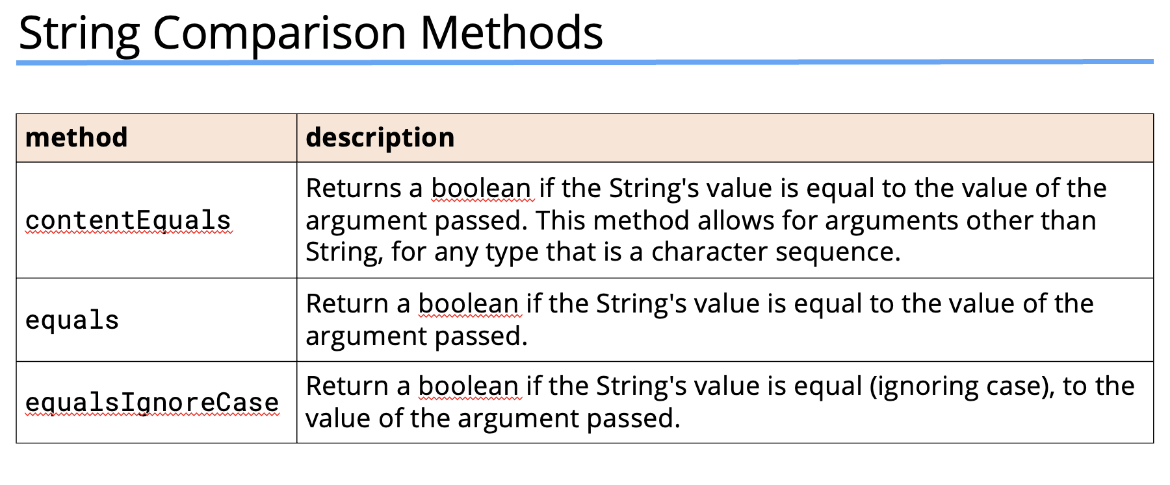
Equals: Not only checks each individual content, but also check if the object is an instance of the String.
ContentEquals: compare string content takes any implementation of CharSequence interface as an argument. E.g String, StringBuffer, StringBuilder, Charbuffer or segment can be compared.
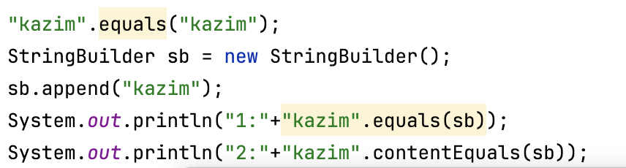

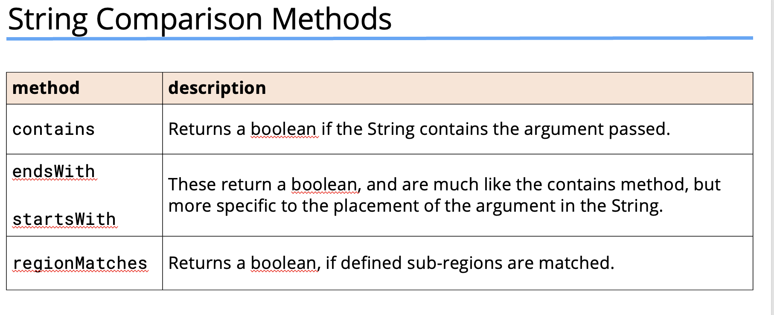
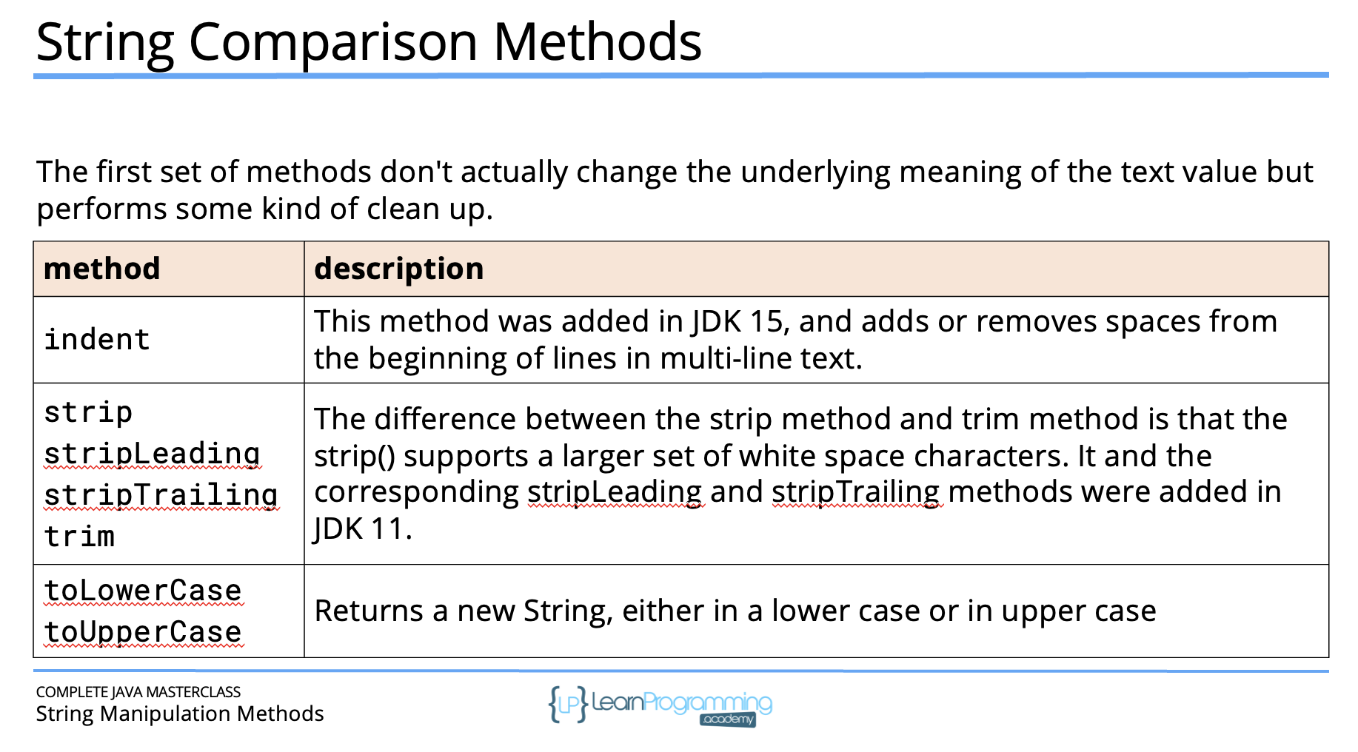
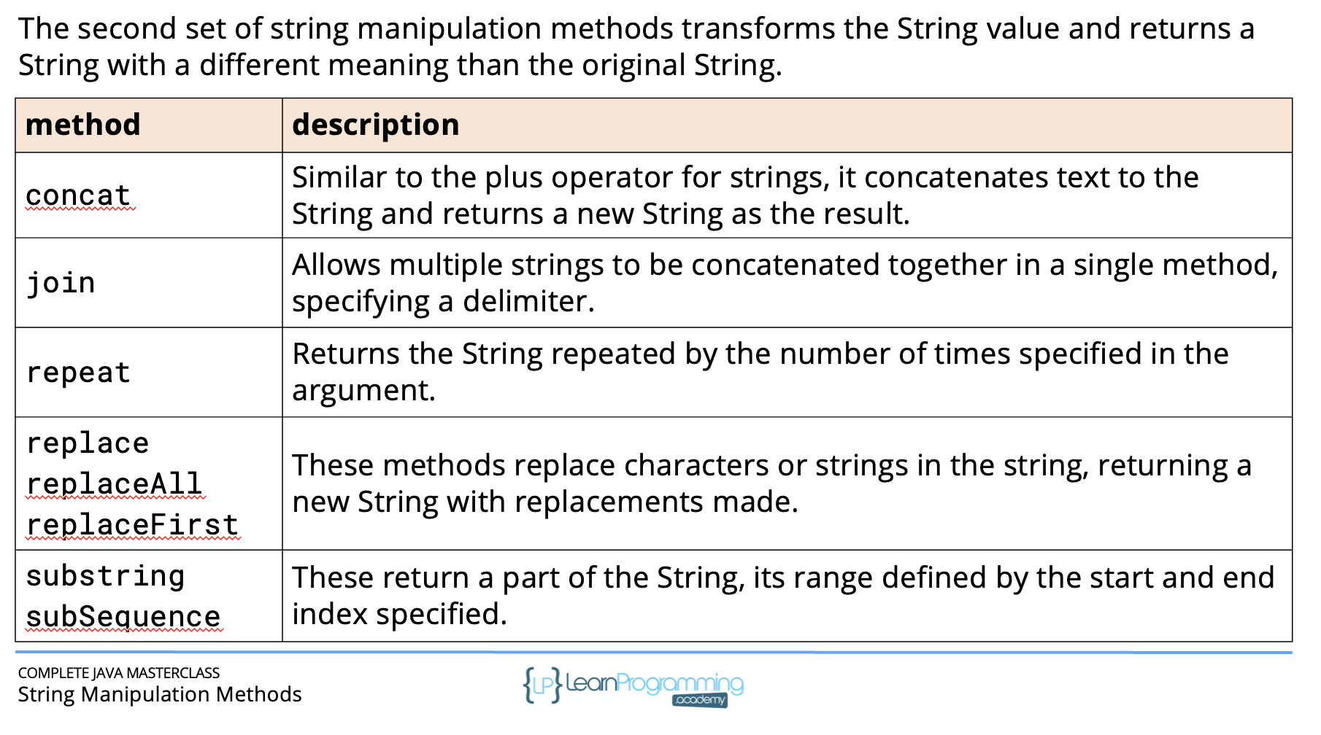

Tips:

What happens when you assign a value of type double to a variable of type int without explicit casting?
Compilation error occurs
When you try to assign a value of type double to a variable of type int without explicit casting, a compilation error occurs. This is because Java does not allow implicit narrowing conversions (converting from a larger data type to a smaller one) to prevent potential loss of data. To perform this operation, you must use explicit casting, like: int x = (int) doubleValue;

Which of the following is the correct way to use the logical AND operator in Java?
A && B
The correct way to use the logical AND operator in Java is 'a && b'. This is the short-circuit AND operator, which only evaluates the second operand if the first operand is true. Option 2 (a & b) is the bitwise AND operator. Option 3 (a and b) is not valid Java syntax. Option 4 (a || b) is the logical OR operator.

String a = "10";
int b = 20;
System.out.println(a + b);

Explanation:
The output will be '1020'. In Java, when you use the + operator with a String and another type, the other type is automatically converted to a String, and the operation becomes string concatenation. So, '10' + 20 results in the string '1020'. If you want to perform arithmetic addition, you would need to convert the String to an int first.

int x = 5; System.out.println(x++); x = x++ + ++x;
The final value of x is 14. Let's break it down:
1. Initially, x is 5.
2. System.out.println(x++) prints 5, then increments x to 6.
3. In x = x++ + ++x:
- x++ uses the current value (6) then increments x to 7.
- ++x increments x to 8 before using it.
- So, the calculation is 6 + 8 = 14.
4. x is assigned the value 14.
5. After the statement, x becomes 14 because the x++ in the previous step incremented it one last time

double a = 0.1; double b = 0.2; System.out.println(a + b == 0.3);
False
The output is false. This is due to the way floating-point numbers are represented in binary. Most decimal fractions cannot be represented exactly as binary fractions, leading to small rounding errors. In this case, 0.1 + 0.2 is slightly larger than 0.3 when represented in binary floating-point. For precise decimal calculations, it's recommended to use BigDecimal instead of double.

char c = 65; System.out.println(c);
The output is 'A'. In Java, char is a 16-bit unsigned integer type that represents Unicode characters. When you assign an integer value to a char, it's interpreted as the Unicode code point for a character. The Unicode code point 65 corresponds to the uppercase letter 'A'. This demonstrates that characters in Java can be treated as integers, which allows for arithmetic operations on characters.

String is not a primitive data type in Java. It's a class in the java.lang package. The primitive data types in Java are byte, short, int, long, float, double, boolean, and char. String is a reference type that represents a sequence of characters.

Python vs Java

Python is Dynamic type: variables are not bound to specific type. And type check are performed at runtime. | Java is statically type: u have to explicitly declare variable type which makes it easier to catch type related errors during compile time rather than runtime.
Quick Script | More Verbose , harder to write Quick Scripts
Quick Development but less explicit type safety | Large scale, Maintainable applications
Interpreted Language: Slower execution, not for performance-intensive task, especially those requiring extensive CPU operations. | Java is compiled language, rather than compiling it directly to machine code, It is compiled into byte code, which runs on JVM. JVM optimises byte code execution by JIT Compilation, which allows java to achieve near native performance in many cases.
 | Better Multi-threading capabilities, better suited for application that requires concurrency, like large scale server applications.
Excellent for data science, ML, scripting | Extensive for enterprise, network, and GUI applications
Faster development, ideal for prototyping such as Minimum viable | Slower due to verbosity, better for large-scale systems

Platform independent vs cross-platform.
In Platform independent, u don’t need to recompile or modify your code to run in a different OS. In Java, the bytecode aka machine remains the same for JVM. The coressponding JVM then translates into the instructions that the OS can understand. In Cross-platform, u have to make slight tweaks and modifications to support different
OS. Is this why when we download jdk we make sure the x32 or x62 bit?

New info, JVM translates the bytecode at runtime.

Java
Platform independent | Source code can run on different operating systems
Platform Independence: | Java is platform-independent because it runs on the JVM. Java code is compiled into an intermediate form called bytecode, which is not tied to any specific operating system.
JVM | The Java Virtual Machine (JVM) is the engine that executes Java bytecode. It provides a runtime environment for Java applications, enabling them to run on any device or operating system that has a JVM.
JVM | java Virtual Machine is a thing in which Java apps run. You see, Java code, programmer telling computer what to do, is compiled into instructions that only a Java machine understands. Your computer isn't a Java machine however(there are a couple of such things in existence), and it doesn't understand those instructions. What to do? Enter JVM. Your computer can simulate workings of Java machine. And because it's virtually simulated, it's called Java Virtual Machine. Running Java program therefore consists of booting up the Java virtual machine, inputting the code into that virtual machine, and then checking the results.
 | your CPU doesn't run the code directly, instead the virtual machine is the one that runs it.
JRE | JRE is Java Runtime Environment. It's a set of programs and libraries used to run Java code. This includes the JVM as well as the Java Standard Libraries (for example where classes such as String and ArrayList are written).
 | JDK is Java Development Kit. It includes the JRE as well as programs for actually creating Java programs, such as the Java compiler.
 | Well, the bytecode is a form of machine code. It's machine code for the JVM. But the JVM's job is to interpret that and convert it into machine code for the computer it's running on.

Compiler, interpreter, Runtime, IDE

Imagine u write some instructions for a toy robot in a language he doesn’t understand. So a compiler will translate those instructions that it can understand all at once.
Once translated, the toy robot can follow those instructions without the need of translator.

Interpreter: you are telling the robot instructions step by step, and the translator translate the code each step as you go. It is slower than compiler to follow in real time.

Runtime: This is when the robot is actually executing the instructions. After the instructions have been translated(either by compiler or interpreter) the robot starts following them. The runtime is when the code is actually running.

IDE time: when the code is being written and checked for syntax errors or problems detected by the IDE. Error at this phase must be resolved before the code can be built and compiled.

—
Instruction are called source code.
Source code is translated in a language computer processor understand.
The output is an executable file that can run independently.
So once compiled, the program doesn’t need to go through the the compiler again to run.
So a compiled executable is standalone file that can distributed to others and can be executed w/o the need to install the compiler.
Since, its pre-translated, it often results in efficient execution.
Generates a separate file like in java is javac.

Interpreter are easier to debug and run in real time. Translates HLL code Line by line. This happen to be slower cause the translation happen at the runtime. It’s easier to
Test and Debug Since u can immediately see the effects w/o the need to compile and re-run the whole program. Because the interpreter stop and tells where the logical error happened. For performance sensitive application this can be a drawback.

Runtime environment: is collection of resources, libraries and services needed for the program to run java programs. They handle memory management,
Access to system resources, built-in services or libraries that program can use. For java, the JRE includes the components required for java program to execute. Runtime
Also involves handling things like I/O, network connections, error handling as the program operates.

—
Source code in HLL into machine code OR byte code i.e LLL code that OS and CPU can understand.
Once compiled, the o/p is an executable file (.exe or native binary for MacOS/Linux) that can be run by the OS
A windows program designed to run on windows only is a native binary.
A non-native binary would be like a java program that runs on different platforms but requires a Java Virtual Machine to run you could not just run it like native binary program.
ok

—
IDE is a set of tools in one platform, compiler or interpreter, version control, debugger, emulator or simulator(to test how ur code works behaves in different environments)

Access modifiers in Java

Modifier | Class | Package | Subclass (Inheritance) | World (Anywhere)
private | ✅ | ❌ | ❌ | ❌
Default (no modifier) | ✅ | ✅ | ❌ | ❌
protected | ✅ | ✅ | ✅(even In diff pkgs) | ❌
public | ✅ | ✅ | ✅ | ✅

Your class name can either be public or private of package private. While top-level class can’t be protected, nested or inner class can.
Private class is used for encapsulation(hiding inner details).
Public class: Used for APIs, libraries, and global access.
Your class can’t be be protected?
Logical Inconsistency
- protected means "accessible in subclasses (even in different packages)."
- But if a top-level class itself isIf Parent is protected, no outside class can see it to extend it.

protected, how would you extend it from another package if the class isn’t visible there in the first place?
If Parent is protected, no outside class can see it to extend it.

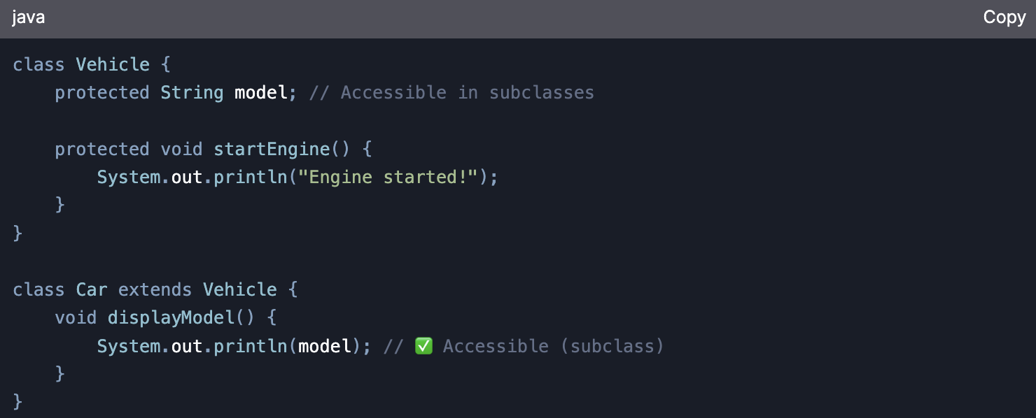

Access modifiers for class:
A top level class(not nested) can be public or package private(defualt).
If a class is public, its file name must match the class name.
public class Student { } // ✅ (File must be "Student.java")
class Teacher { } // ✅ (Default access, file name can differ)

When to Use Which?
Scenario | Recommended Modifier
Internal class logic (helper methods) | private
Package-specific utilities | default
Methods/fields for subclasses | protected
API methods, constants, main class | public

package com.example;

public class AccessExample {
private int secret = 123; // Only in this class
int packagePrivate = 456; // Only in com.example
protected int forSubclasses = 789; // Package + subclasses
public int globalAccess = 999; // Everywhere
}

FAQ

Can We Create a Subclass in Someone Else's Package?
- No, you cannot arbitrarily add a class to someone else's package (like com.library).
- Packages are meant to encapsulate code, and you should not modify third-party libraries.
- Instead, you extend their classes in your own package (as shown above)

- Some classes are designed to be extended but not instantiated directly (e.g., abstract classes or classes with protected constructors). You can extend Parent class with protected constructer.
If a class is declared final, it cannot be subclassed at all.

Key Takeaways
Scenario | Can We Extend? | How?
Class is public + protected members | ✅ Yes | Extend in your package
Class has protected constructor | ✅ Yes | Call super() in subclass
Class is final | ❌ No | Use composition/interfaces
Class is package-private (default) | ❌ No (unless same package) | Not possible in a different package
Third-party library class | ✅ If public/protected | Extend in your own package
Best Practices
- Prefer composition over inheritance when dealing with third-party code.
- Use interfaces when possible for flexibility.
- Respect protected—it’s meant for controlled extension, not direct access.

I didn’t understood some points below as of now.

What Should You Do Instead?
- Need subclassing across packages?
  - Use public class + protected methods.
- Need package-only visibility?
  - Use default (no modifier) class.
- Need nested class inheritance?
  - Use protected static class.

Note:
- protected = Package + Subclasses (anywhere).
- Subclass in another package can:
  - Inherit and override protected methods.
  - Call them only within the subclass (not on parent instances).
3. Users can always instantiate their own subclass (if the parent is public).
This ensures controlled inheritance while allowing flexibility for library users. 🚀

1. protected Method Access Rules
Scenario | Accessible? | Explanation
Same class | ✅ Yes | Always accessible.
Same package (non-subclass) | ✅ Yes | Behaves like default.
Subclass in same package | ✅ Yes | Inherits and can call directly.
Subclass in different package | ✅ Yes | Can only access via inheritance (not direct instance).
Non-subclass in different package | ❌ No | Cannot access (even if class is public).

Within the same package, aka within the library u can create an instance of a class and call its protected method w/o the need to class its subclass.
--

Key Takeaways
Scenario | Why protected? | Example
Reusable logic for subclasses | Avoid exposing internals | Template methods
Internal helpers | Keep public API clean | calculateTax()
Same-package collaboration | Share code safely | repaint()
Restrict risky operations | Limit access to trusted subclasses | overrideSecurityCheck()

When NOT to Use protected
- If the method should be fully public → Use public.
- If the method should never be overridden → Use private or final.

Final Answer
protected methods strike a balance:
✅ Subclasses can reuse/modify them (unlike private).
✅ External code can’t misuse them (unlike public).
✅ Same-package classes can collaborate (unlike public).
They’re essential for designing extensible, maintainable libraries

why runtime polymorphism isnt' determined at compile time?
Runtime polymorphism, or dynamic binding, isn't determined at compile time because , allowing flexibility in choosing which method to execute based on the object's runtime type.
Because it is determined by the logic flow.
For e in list:
obj=list[round(random.randint()*len(list))]
obj.deadift()

StringBuilder & StringBuffer
Why not String | Because String is immutable, And that creates a new object(wastes memory) whenever we concatenate or append. So StringBuilder and StringBuffer are mutable.
String str=”Hello”
str+=”Kazim”

Feature | StringBuilder | StringBuffer
Thread Safety | Not thread safe | Thread safe
Performance | Faster | Slower
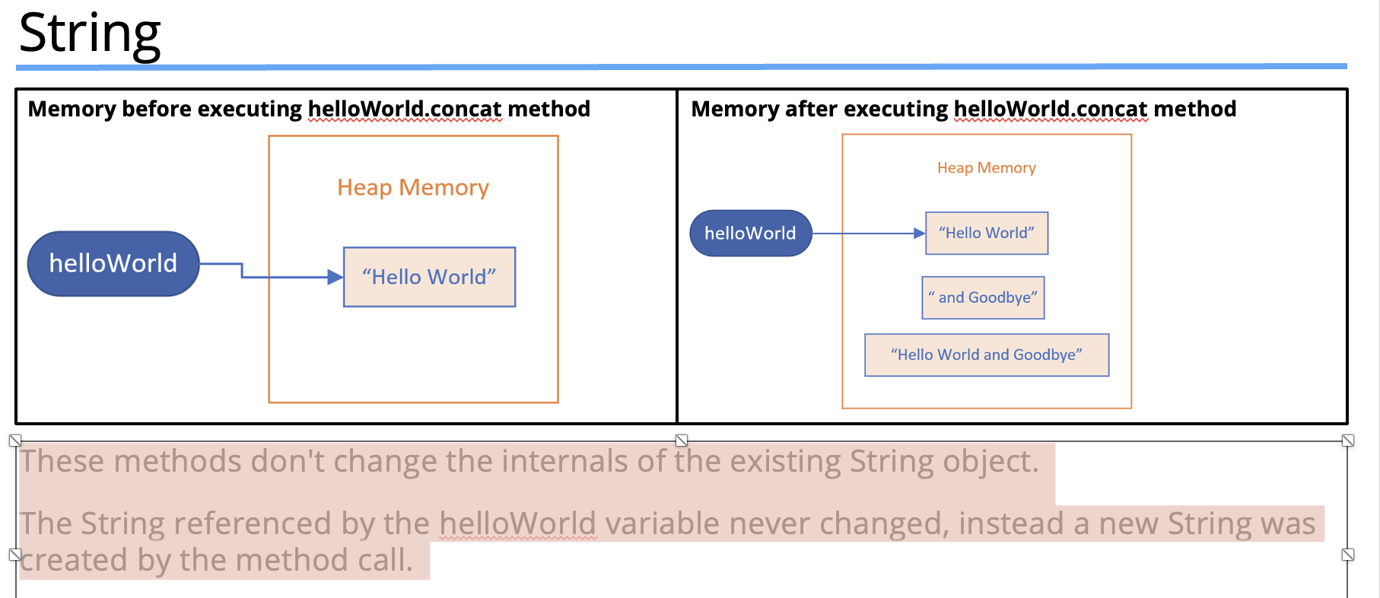

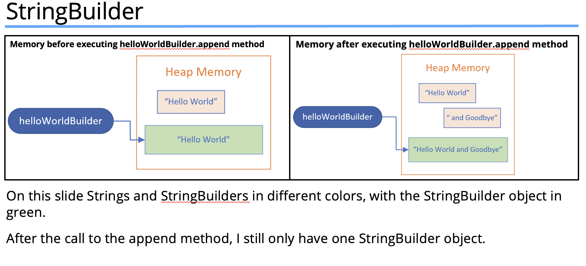

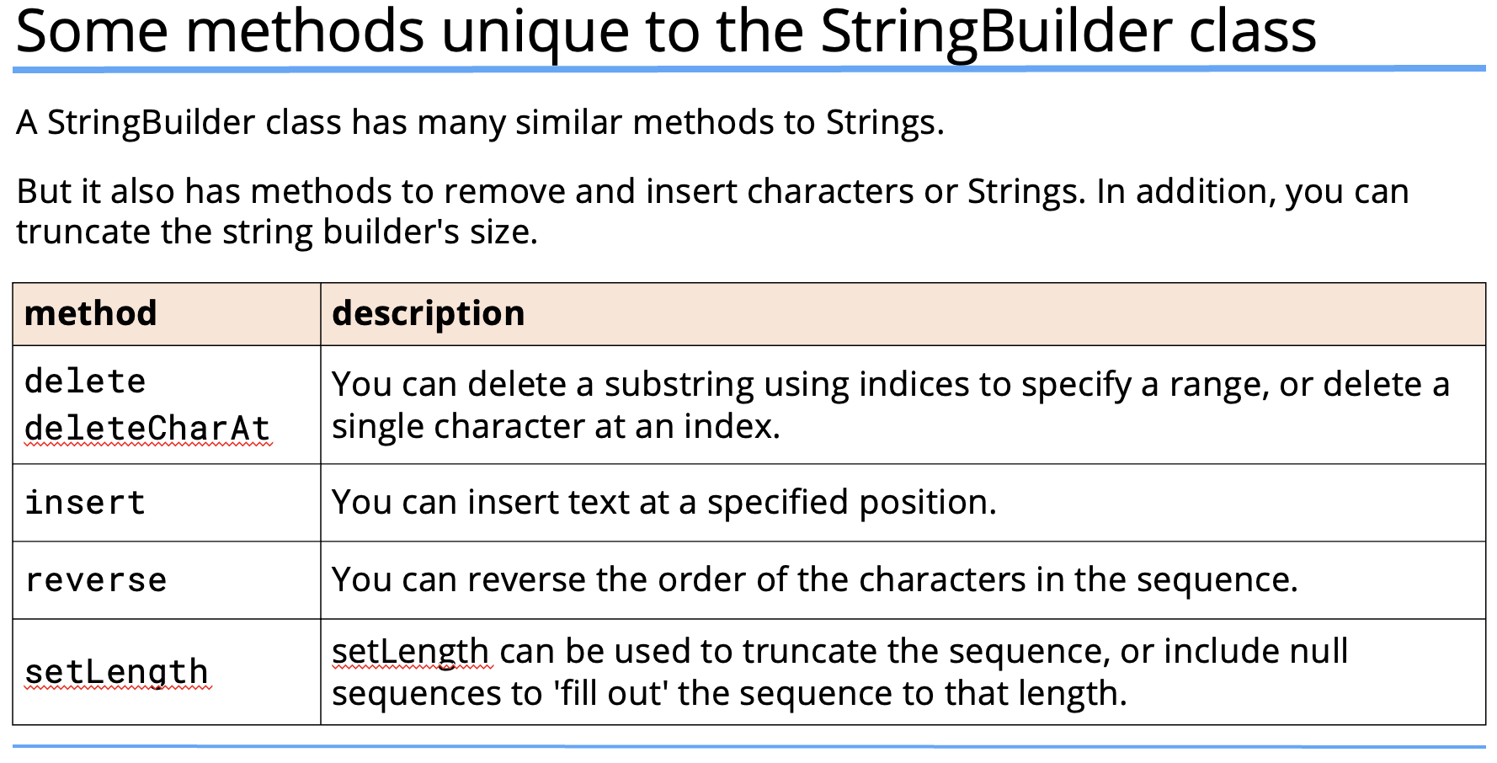

Use String buffer by default  Only use StringBuffer if multiple threads modify the same String. | // StringBuilder (Recommended for most cases)  StringBuilder sb = new StringBuilder("Hello");  sb.append(" World"); // Modifies same object  System.out.println(sb); // "Hello World"  // StringBuffer (Only needed for thread safety)  StringBuffer sBuffer = new StringBuffer("Hello");  sBuffer.append(" Java");  System.out.println(sBuffer); // "Hello Java

Stream operations(boxed(), collect(), filter()) Allow function style operations on collections
List<Integer> numbers = List.of(1, 2, 3, 4, 5);

// Get only even numbers
List<Integer> evens = numbers.stream()
.filter(n -> n % 2 == 0)
.collect(Collectors.toList());

System.out.println(evens); // [2, 4]
boxed() | Converts primitive streams to object streams.
Boxed stream is needed because instream doesn’t work directly with collectors. | IntStream intStream = IntStream.of(1, 2, 3);  // Convert IntStream to Stream<Integer> (to use collect())  List<Integer> list = intStream.boxed()  .collect(Collectors.toList());  System.out.println(list); // [1, 2, 3]
List<String> names = List.of("Alice", "Bob", "Charlie");

// Convert to UPPERCASE and collect into a List
List<String> upperNames = names.stream()
.map(String::toUpperCase)
.collect(Collectors.toList());

System.out.println(upperNames); // ["ALICE", "BOB", "CHARLIE"]

98. Revisiting the String: Method and best practices
108. Polymorphism
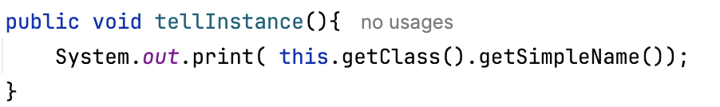

It gets the className, different child classes would have different name.

